2022
Hay River Review
May 26, 2022
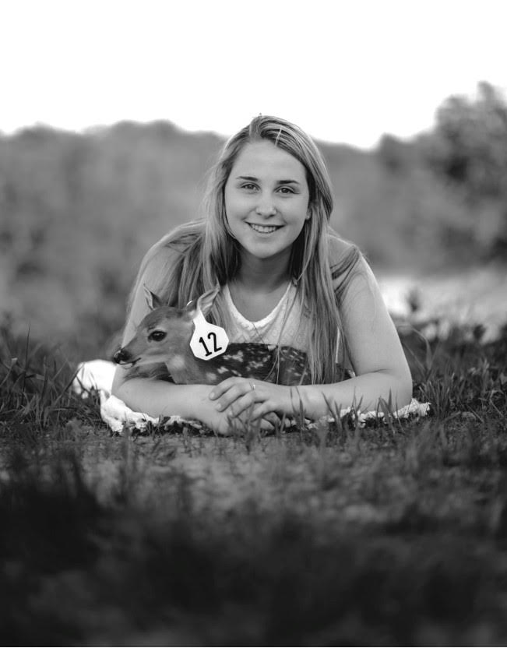
Wisconsin Cervid Farmers’ Foundation (W.C.F.F.), which is the educational arm of Whitetails of Wisconsin (W.O.W.), awarded a $500 scholarship to Samantha Bowers at the W.O.W. Annual Spring Meeting held at The Three Bears Resort in Warrens, Wisconsin March 12, 2022. According to W.C.F.F., Samantha is one of four winners selected each year. The applicant is either a member of W.O.W. or a child/grandchild of a member.

Samantha attended Prairie Farm High School and will be studying a degree in Nursing at Northwood Technical. She is the daughter of Chad and Michelle Bowers, members of Whitetails of Wisconsin since 2014. Behind Samantha’s success included honor roll, being a continued Officer in FFA, being a key leader in the Fruit Sale and Strawberry Sale activities, sharing her passion for agriculture by teaching and leading stations at the Food for America and Ag in classroom events, FCCLA, volunteering at various community organizations and continuing as a member of the Ice Fishing Team. Samantha received a $1000 grant through FFA for a project she did a couple years ago for the family deer farm. She purchased her own deer and has been an active part of the day-to-day duties on the farm since they began.

W.O.W. is an association representing an industry that has an annual economic impact on Wisconsin’s economy of $75 million. W.O.W. is a political voice for approximately 400 deer breeders in Wisconsin. They represent the deer industry by working closely with state and federal legislators and regulatory agencies to develop rules and regulations that govern the deer industry.

W.C.F.F. dedicates the promotion of deer farming and ranching as an agricultural pursuit. The Foundation serves its members through educational programs, research and publications providing industry leadership while maintaining quality industry standards.

